Lecture 04B Homework

Implement the queries below using the db02 database

Work independently.

Put your queries into a submission file per earlier instructions. Name the file ‘04BQueries.txt’

1 – Find the number of attendees in each meeting, as well as the capacity of the room and the creator ID

Column Names: **id, butsinseat, capacity, creatorid**

Order by creatorID

*Note – this query will be very useful in the next problem.*

2 – For each creator of a meeting. Find the total number of attendees in their meetings, the total capacity of all of their meetings, and the available number of seats in all their meetings.

Column Names: **name, attendees, capacity, availseats**

Order By availseats

3 – Find the name of the employee who is attending the most meetings. Compute a number ( maxMeeetings) which is 75% of the total number of meetings for that person.

Column Names: **name maxmeetings**

4 – Find all employees who are attending almost as many meetings as the most prolific meeting attender. ‘almost as many’ is defined as attending 75% of the number of meetings the most prolific meetening attender attends.

Column Names: **name, numMeetings**

Order by numMeetings;

5 – Find the average room utilization for all rooms occurring on 2018-03-04 at 10:00 AM . Express the utilization as a percentage value which is ‘total number of rooms with meeting’ / ‘total number of rooms’

Column Names: **Util in %**

6 – Find any employees who are double booked for any meeting. Double booking is defined as attending two meetings that start at the same time.

Column Names **name, nummeetings, starttime**

Order By name

7 – Find the number of employees we have for each phone type. ( Cell, Home etc)

Column Names category, num_employees

Order By category

8 – Find the number of phone listings we have for each phone type ( Cell, Home, etc)

Column Names: category, num_listings

Order By category

*Note – the difference between #7 and #8 is that if an employee has 2 phone numbers of*

*The same type – under #7 it would increase the count by 1. In #8 it would increase the count by*

*2*

9 – Find the number of cell phones in each meeting that takes place in building B

Column Names: **meetingid, purpose, numphones**

Order By meetingid

10 – Find the average number of cell phones in each meeting in building B Display answer to two decimal places

Column Names: **avg_phones**

11 – Find the total number of phones, and average number of phones for each building in building B

Column Names: **purpose numphone avg_phones**

Order By purpose, meeting.id

for each phone listings for each type of phone ( Cell, Home, Pager etc)

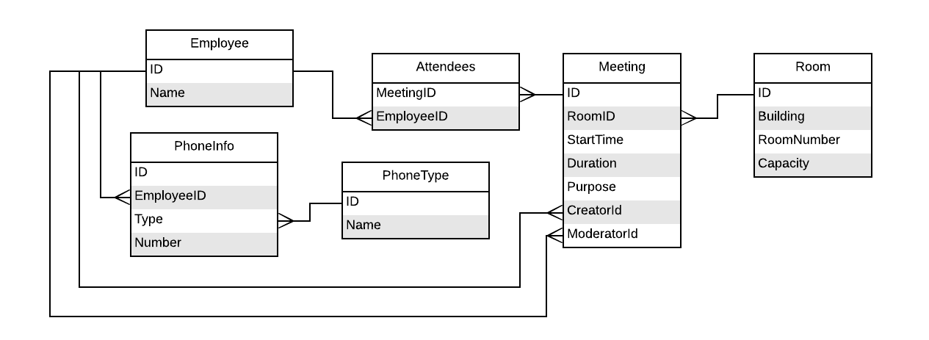

**Expected Output**

Expected output from homework 4B

#1 Get total number of attendees and capacity for all meetings created by each employee

( This query will be useful in #2)

id | butsinseat | capacity | creatorid

-----+------------+----------+-----------

105 | 6 | 20 | 3

115 | 7 | 20 | 3

107 | 3 | 5 | 3

106 | 7 | 20 | 3

109 | 6 | 20 | 5

116 | 6 | 5 | 5

108 | 4 | 20 | 6

110 | 14 | 30 | 11

113 | 7 | 20 | 14

111 | 6 | 30 | 14

114 | 6 | 20 | 14

103 | 8 | 10 | 14

101 | 6 | 10 | 14

102 | 6 | 10 | 14

104 | 6 | 10 | 14

112 | 6 | 20 | 14

(16 rows)

#2 - By creator. How many total attendes in meeting they have created,

what is the capacity, and what are avail seats.

name | attendees | capacity | availseats

---------+-----------+----------+------------

Dan | 12 | 25 | 13

Jack | 14 | 30 | 16

Ariel | 4 | 20 | 16

Winston | 23 | 65 | 42

Alice | 51 | 130 | 79

(5 rows)

#3 print the employee attending the most meetings,

and print 75% of the total number of meetings

name | maxmeetings

------+-------------

Dave | 8.25

(1 row)

#4 Return all employes who are attending more that 75% of the employee

with the most meetings

name | nummeetings

--------+-------------

Albert | 9

Jack | 10

Dave | 11

(3 rows)

#5 - Find average utilization of rooms as percentage value, for any meetings

occuring on 2018-03-04 at 10:00 AM

Util in %

-----------

22

(1 row)

#6 Find any employees who are double booked in meetings

Show name, how many meetings, and start time of meeting

double booking is defined as two meetings starting at same time

name | nummeetings | starttime

--------+-------------+---------------------

Albert | 2 | 2018-03-28 12:00:00

Ariel | 2 | 2018-03-28 12:00:00

Sarah | 2 | 2018-03-18 09:30:00

Sarah | 2 | 2018-03-18 09:30:00

(4 rows)

#7 Show how many employees we have using each phoen type

category | num_employees

----------+---------------

Cell | 10

Home | 7

Pager | 3

Work | 15

(4 rows)

#8 Show how many phone listings we have for each phone type

category | num_listings

----------+--------------

Cell | 10

Home | 8

Pager | 3

Work | 15

(4 rows)

#9 Number of cell phones in each meeting in building B

( This will be useful in the next query)

meetingid | purpose | numphones

-----------+-----------------+-----------

108 | DB Issues | 3

109 | Post Mortem | 6

110 | HR Presentation | 9

112 | Lunch | 3

113 | Lunch | 4

114 | Lunch | 3

115 | PlanningLunch | 5

(7 rows)

#10 Print the average number of cell phones that attendes have in

meetings in building B

avg_phones

------------

4.71

(1 row)

#11 find number of phones, and average number of phones for

Each meeting in building B

purpose | num_phones | avg_phones

-----------------+------------+------------

DB Issues | 3 | 4.71

HR Presentation | 9 | 4.71

Lunch | 3 | 4.71

Lunch | 4 | 4.71

Lunch | 3 | 4.71

PlanningLunch | 5 | 4.71

Post Mortem | 6 | 4.71

(7 rows)